Assessment Day 1 Report

**PROJECT NAME: [*Special Cakes for All Occasions Website*]**

**DATE: [06/23/2025]**

**Student name [Rodel Talampas]**

**Task 1 – Sub Task 2 (Sourcing Images)**

|  |  |  |
| --- | --- | --- |
| Image | Site | URL |
|  | freepik.com | https://img.freepik.com/free-photo/top-view-delicious-cake-arrangement_23-2148933608.jpg |
|  | | |
|  | freepik.com | https://img.freepik.com/free-photo/square-slice-cake-with-pink-cream-berries-another-slice-red-cake-with-cup-tea_114579-3030.jpg |
|  | | |
|  | pexels.com | https://images.pexels.com/photos/15419532/pexels-photo-15419532.jpeg |
|  | | |

**Task 1 – Sub Task 3 (Digital Tools)**

Table 2 Digital system/tool

|  |  |  |
| --- | --- | --- |
| Type of digital system/ tool | Purpose | Specific functions |
| Integrated development environment (IDE) | An IDE is a Tool used for developing applications. It is short for Integrated Development Environment. | It can be used to build web pages, java applications, .net applications, python applications and so on. |
| Image editing software | An image editing software is used to create stunning images or icons. | It can use to crop, resize, vectorize or fix the color of your images. |
| File transfer protocol (FTP) software | This is a client software that is used to transfer files between local machine to a server. | To deploy the web files created into a web server. |
| Browser | A browser is used to render a webpage. Different browsers may have different rendering on certain models, but new browsers now follow a common framework. | It is use to navigate the content of a website. |

**Task 1 – Sub Task 4 (3 Digital Tools)**

Table 3 Digital system/tool

| Type of digital system/ tool | Name of common digital system/ tool | Key features |
| --- | --- | --- |
| Integrated Development Environment (IDE) 1 | Visual Studio Code | **Lightweight & Fast**: Quick to install, starts up fast, and performs well  **IntelliSense**: Smart code completions based on variable types, functions, and imported modules.  **Multi-language Support**: Works well with JavaScript, TypeScript, Python, Java, Go, C++, and more. |
| Integrated Development Environment (IDE) 2 | IntelliJ | **Intelligent UI**: Code navigation, inspections, and suggestions are tightly integrated.  **Powerful Refactoring Tools**: Rename, move, change method signature, and more with confidence.  **Smart Code Completion**: Deep code analysis for context-aware suggestions. |
| Integrated Development Environment (IDE) 3 | Eclipse | **Enterprise Development**: Strong tools for J2EE and Web development.  **Cross-language Support**: Support for C/C++, PHP, JavaScript, Python (via plugins).  **Code Refactoring & Navigation**: Adequate but less polished compared to IntelliJ. |
| Image editing software 1 | ProCreate | **Realistic Drawing Tools**: Mimics pencils, inks, charcoals, and paints  **Layer System**: Layer blending modes, masks, and grouping.  **Precision Tools**: Drawing guides, symmetry tools, and quick shape recognition  **Animation Assist**: Frame-by-frame animation built in. |
| Image editing software 2 | Canva | **Drag-and-Drop Interface**: Very beginner-friendly, no design experience needed.  **Team Collaboration**: Share designs with others, leave comments, real-time editing.  **Basic Animation**: Animate objects and text for video/social media.  **Cross-Platform Access**: Use on desktop, tablet, or phone. |
| Image editing software 3 | Illustrator | **Vector-Based Design**: Create infinitely scalable graphics (logos, icons, illustrations).  **Advanced Typography**: Full control over kerning, tracking, styles, and OpenType features.  **Precision Drawing Tools**: Pen tool, curvature tool, grid snapping, anchor point control.  **Image Trace**: Convert raster images into editable vectors. |
| File Transfer Protocol (FTP )1 | FileZilla | **Support:** SFTP, FTP, and FTPS support  **Drag-and-drop UI** for easy file transfer  **Security:** Secure file transfer via SSH  **File:** Recursive file searching & filtering |
| File Transfer Protocol (FTP )2 | WinSCP | **Support:** SFTP, FTP, FTPS, and WebDAV support  **Explorer**: Commander & Explorer interface styles  **Security:** Secure file transfer via SSH  **Drag-and-drop UI** for easy file transfer |
| File Transfer Protocol (FTP )3 | Cyberduck | **Support:** SFTP, FTP, WebDAV, Amazon S3, Google Drive, Dropbox support  **Security:** Secure file transfer via SSH  **Bookmark management** with keychain/password manager integration |
| Browser 1 | Google Chrome | **Built-in security**: Safe Browsing, sandboxing, automatic updates  **Extensive extension library** via Chrome Web Store  **Google integration**: Translate, search, voice commands  **Powerful Developer Tools** for web development and debugging |
| Browser 2 | Mozilla Firefox | **Highly customizable**: UI, extensions, and themes  **Syncing**: bookmarks, open tabs, passwords across devices  **Strong security features**: frequent updates, sandboxing, HTTPS-Only Mode  **Speed improvements** via the Quantum engine |
| Browser 3 | Microsoft Edge | **Fast performance** (same core as Chrome)  **Built-in security features**: Microsoft Defender SmartScreen, tracking prevention  **Collections**: organize tabs and content into groups  Built-in PDF reader and annotation tools |

**Task 1 – Sub Task 5 (IDE Selection)**

Visual Studio Code should be a very easy tool to create web pages for the client. It is easy to use and supports different plugins for easy website development. Its feature is rich enough that you feel like working with just the normal file explorer with just an additional text editor. The HTML Plugin (material ui) is intuitive enough as its IntelliSense can make the life of the developer easy. Its folder structuring is simple and images can easily be placed in an images folder under to root directory of the web application.

**Task 1 – Sub Task 6 (Image Editor Selection)**

Canva is my choice as it is very portable. I can use a browser or use my IPad to modify images. Since I am using free images, you can simply upload your images and resize as required. The only caveat though, if you are using a free Canva version, image size and image quality are limited.

**Task 1 – Sub Task 7 (Site Map)**

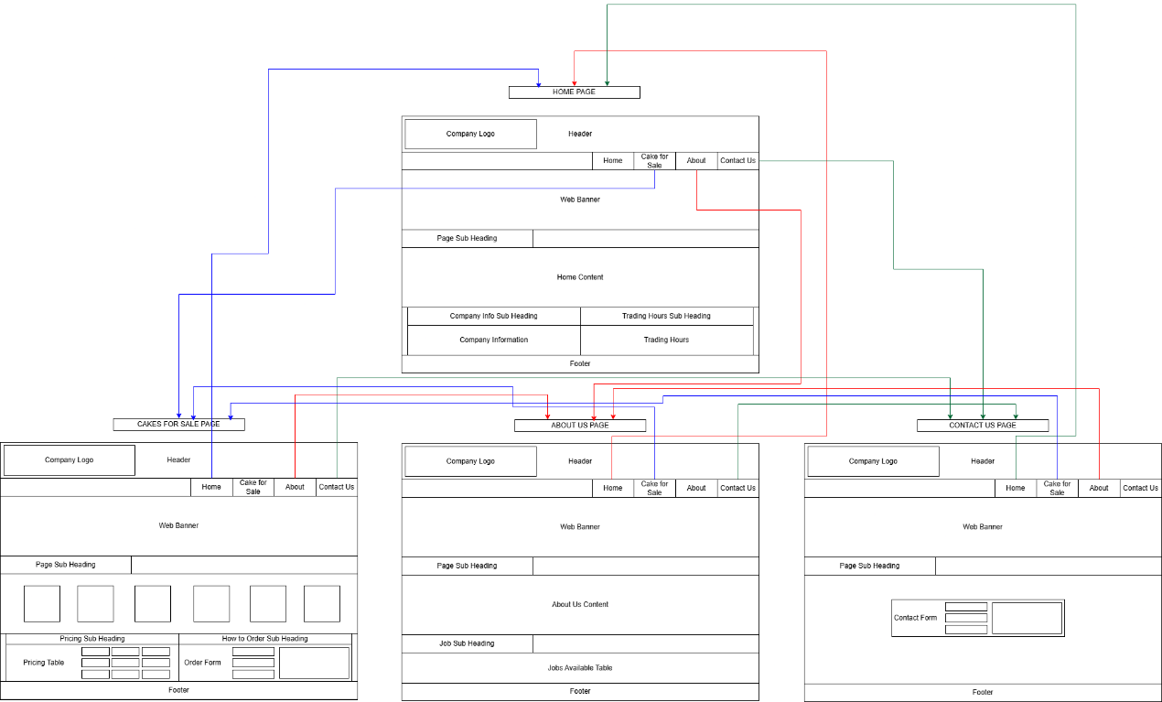

**Task 1 – Images (**Identify 2 suitable image file formats**)**

|  |  |
| --- | --- |
| Type of File Format | Why |
| PNG | Raster (pixel-based)  Excellent Browser Compatibility  Transparency Support |
| SVG | Vector (math-based, not pixel-based)  Infinitely scalable without quality loss  Yes (CSS & JavaScript can animate SVGs)  Transparency Support |